Q

We are hiring!
Techéol is looking for WIND TURBINE TECHNICIANS
You are a highly motivated person who loves to take on new challenge and want to join a dynamic team. Send us your resume at recrutement@techeol.com or by fax at 418 536-5729.
Main task of a wind turbine Technician are:
- Mechanical (preventive and corrective maintenance)
- Electrical (voltage measurement, lockout)
- Inspections (mechanical and electrical) in wind turbines

This is done through constant attention to health and safety procedures.

QUALIFICATIONS AND REQUIREMENTS :
- Experience as wind turbine technician an asset;
- Minimum 5 years of experience in wind energy;
- Experience gained in the operation and / or maintenance of wind turbines. Any other experience deemed relevant for the position (electromechanical, industrial mechanics) will be considered;
- Basic knowledge of English and French;
- Have a valid Class 5 driver's license;
- Be mobile and ready to travel around Canada;
- Be available for additional work and on call when required.

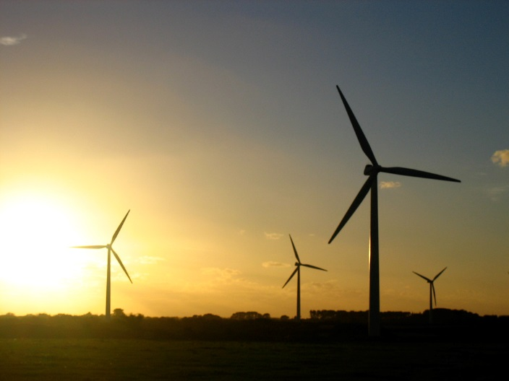
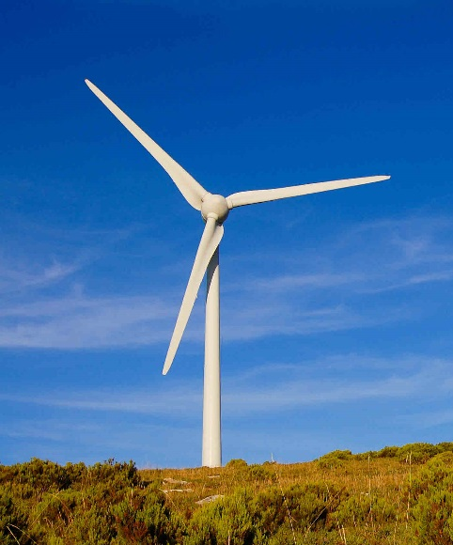
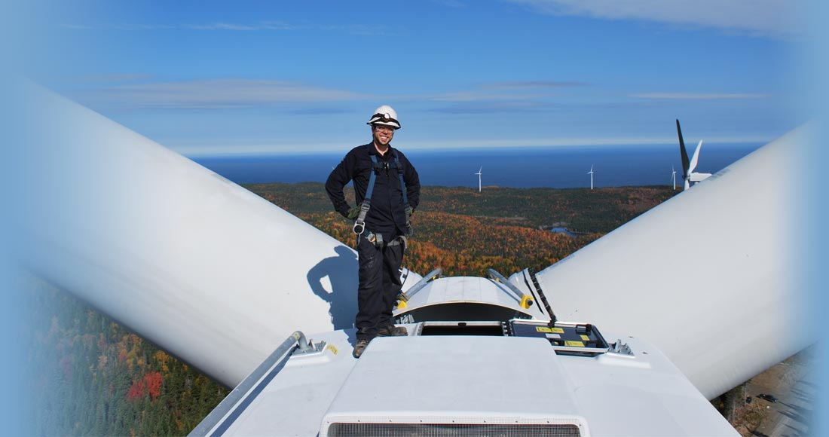
We’re waiting for your application!

